Dear __.

We are facing problem update CYPD3175 FW via Power Board

We selected CCG3PA Power Adapter with Direct Feedback Control example from Power SDK

We used PSoC creator 4.2.

# Custom board base on CYPD3175

# Power board CY4532

# Using the CY4532 Power Board as a Programmer (base on EZ-PD™ CCG3PA Evaluation Kit Guide.pdf)

# Bootloader version in above example

## Path bootloader in power SDK:

* C:\Program Files (x86)\Cypress\EZ-PD CCGx Power SDK\CCGx\Firmware\projects\CYPD3175-24LQXQ_pa_direct_fb\CYPD3175-24LQXQ_pa_direct_fb.cydsn\Bootloader
* .\Bootloader\CYPD3175-24LQXQ_cc_src_boot_3_1_2_1484_0_0_0_pa.hex
* .\Bootloader\CYPD3175-24LQXQ_cc_src_boot_3_1_2_1484_0_0_0_pa.elf

## See Appendix A1 , Appendix A2

## Bootloader version of cypd3175 (first connection via power board) we read device via Cypress EZ-PD™ Configuration Utility) –see Appendix A3

## Bootloader parameters and build-in configuration in PSoC IDE

### Parameters –Appendix A5

### Build-in –Appendix A6

## Boards, Cables, and Accessories Needed

The following items are needed to use the CY4532 Power Board as a Programmer:

* Items provided with the kit:
  + CY4532 Power Board
  + 12 V 50.4 W DC power adapter
* Items not provided with the kit:
  + Hardware with Cypress EZ-PD CCGx product supporting CC bootloading feature
  + A USB Type-C Electronically Marked Cable Assembly (EMCA) cable
  + A USB Micro-B Cable
  + PC/Laptop installed with the Cypress EZ-PD Configuration Utility

**Note**: The CY4532 kit installer installs the EZ-PD Configuration Utility by default.

### Using the CY4532 Power Board as a Programmer

1. Remove the power supply connected on the DC Jack (J3) of the CY4532 Power Board.
2. Detach the CY4532 Main Board pre-mounted on top of the CY4532 Power Board.

**Note:**

* + To remove the CY4532 Main Board, it is recommended to hold it around the longer edges of the board and lift it up.
  + No specific jumper setting is required on the CY4532 Power Board to use it as a Programmer.

1. Connect a USB Type-C EMCA cable between the USB Type-C port (J13) of the CY4532 Power Board and the USB Type-C port on the external hardware.
2. Connect the USB Micro-B cable between the USB Micro-B port (J12) of CY4532 Power Board and a USB Type-A port of the PC/laptop.

**Note**: For the Rev ** of the CY4532 EVK, use USB Type-A to Mini-B cable.

1. See Appendix A4
2. Connect the 12 V DC power adapter provided with the kit to the CY4532 Power Board’s DC Jack (J3).
3. Set the Switch (SW1) on the Power Board to the ‘DC INPUT’ position.
4. Invoke the EZ-PD Configuration Utility on the PC/laptop and follow the programming procedure described in the User

## After first FW update we get following message box



## The second attempt failed because power board does not recognize cypd3175 device

## 

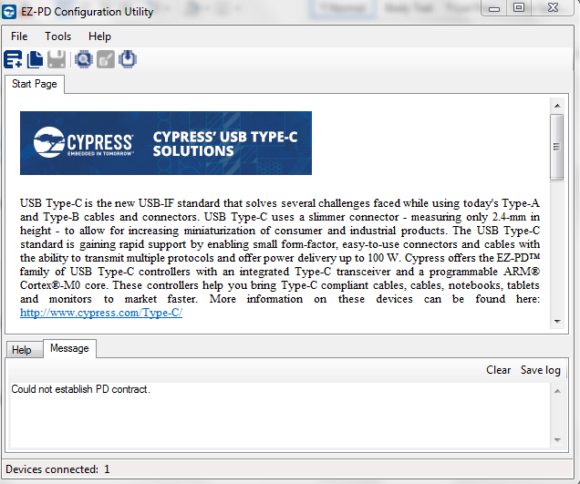

## Questions:

### Q1: what steps we need to do in order require ability FW update via power board ?

### Q2: does bootloader we use support "bootloading via cc lines" feature if not please provide or we need implement one?

Appendix

# Appendix A bootloader in PSoC IDE

## Appendix A1

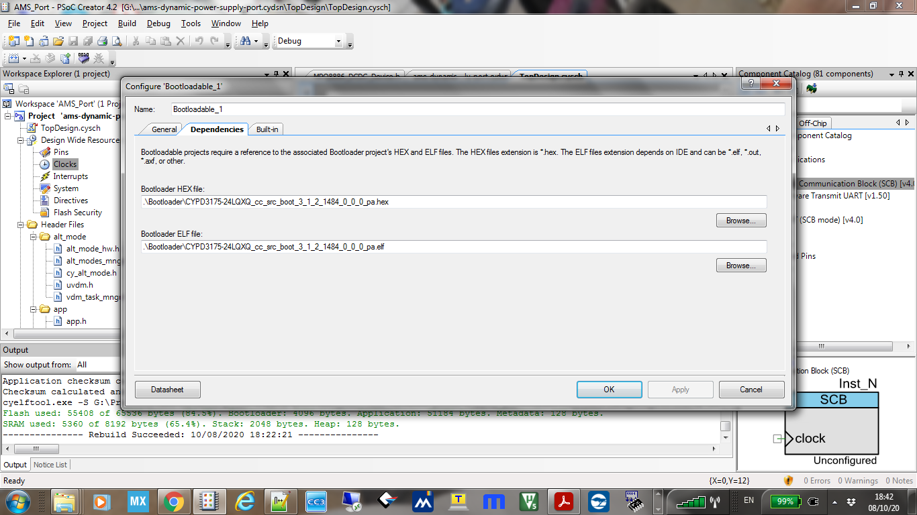

## Appendix A2

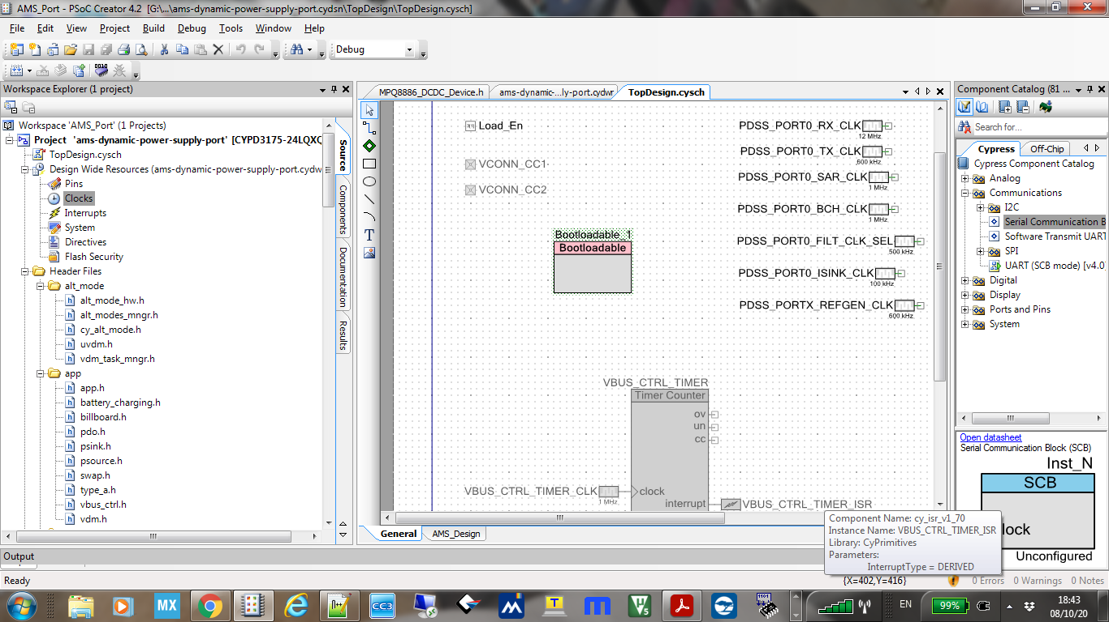

## G:\Projects\ams-power-supply\Documentation\FW upgrade via power Board\2 connecting to cypd3175.PNGAppendix A3

## 

## Appendix A4

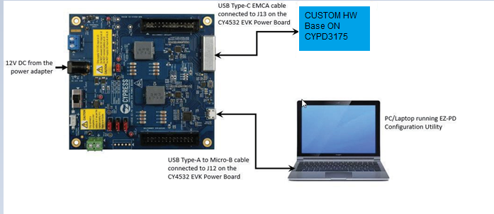

## Appendix A5

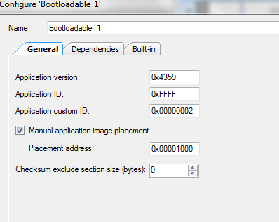

## 

## Appendix A6

