The general steps to setup up MIPI CSI camera solution with CX3 – KBA225748
Question: What’re the general steps to setup up MIPI camera solution with CX3?
Answer: This KBA will explain the general steps to setup up MIPI camera soliton with CX3.
CX3 is a MIPI CSI-2 to super speed USB bridge controller. The physical layer of CX3 is D-PHY. Consequently, CX3 could interface with MIPI CSI-2 sensors but not MIPI CSI-3 sensors. Please check the datasheet of CX3 for more information.
- Open EZ-USB SDK. Click the icon below to open the CX3 configuration tool.
Fig.1 Start a new project

- Fill up the blanks.

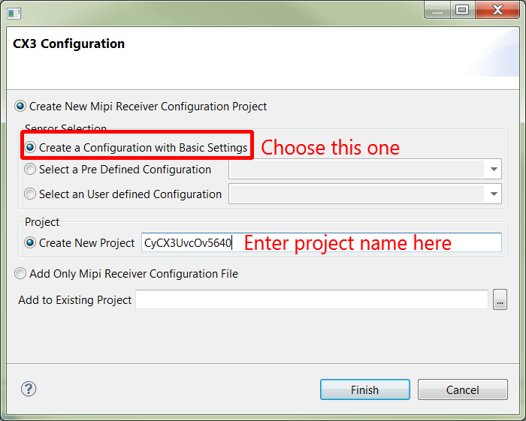
Fig.2 Enter the project name

- After clicking finish, a new project will appear in the explorer panel with blank MIPI configuration.
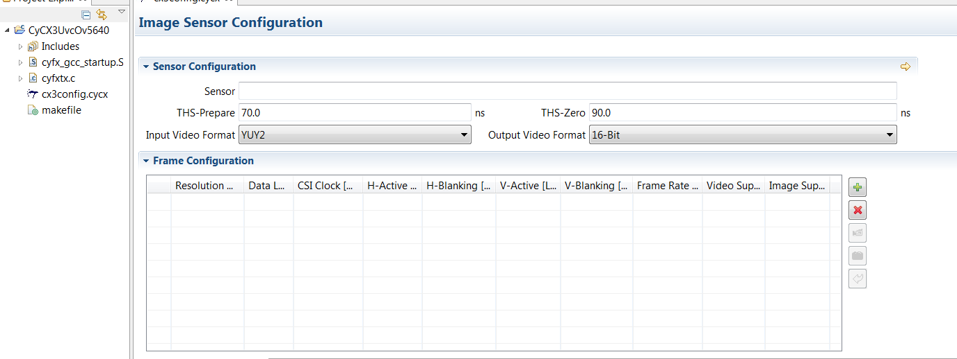
Fig 3. New project

- Enter the necessary parameters for a new resolution.
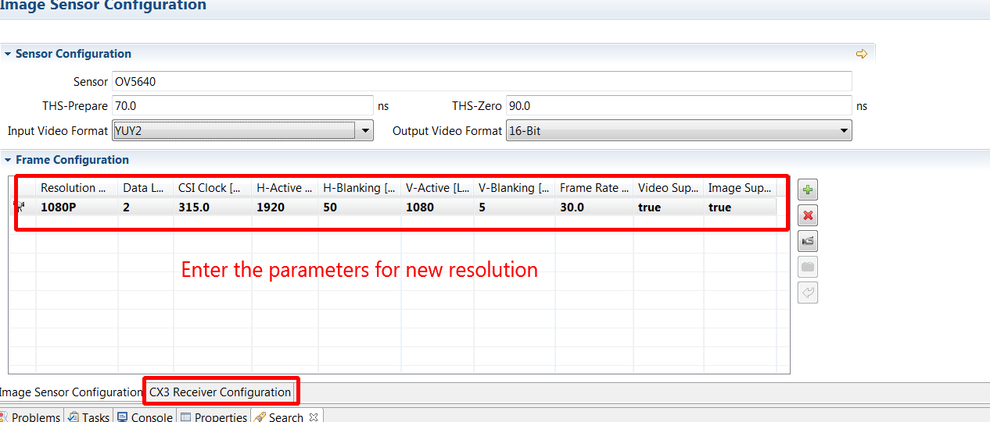
Fig 4. Specify a new resolution
Note: Some explanations to the terminologies above.
- THS-prepare and THS-zero are the values defined in MIPI CSI-2 D-PHY specification. Contact the sensor vendor to get the correct value.
- Input video format: this item is used to identify the data format from image sensor or ISP.
- Output video format: this item is used to choose whether 16-bit or 24-bit parallel data bus is used inside of CX3.

- Click CX3 receiver configuration tab. The tool will lock the values in previous tab so that they are not editable here. If you want to modify them, back to the image sensor configuration page.
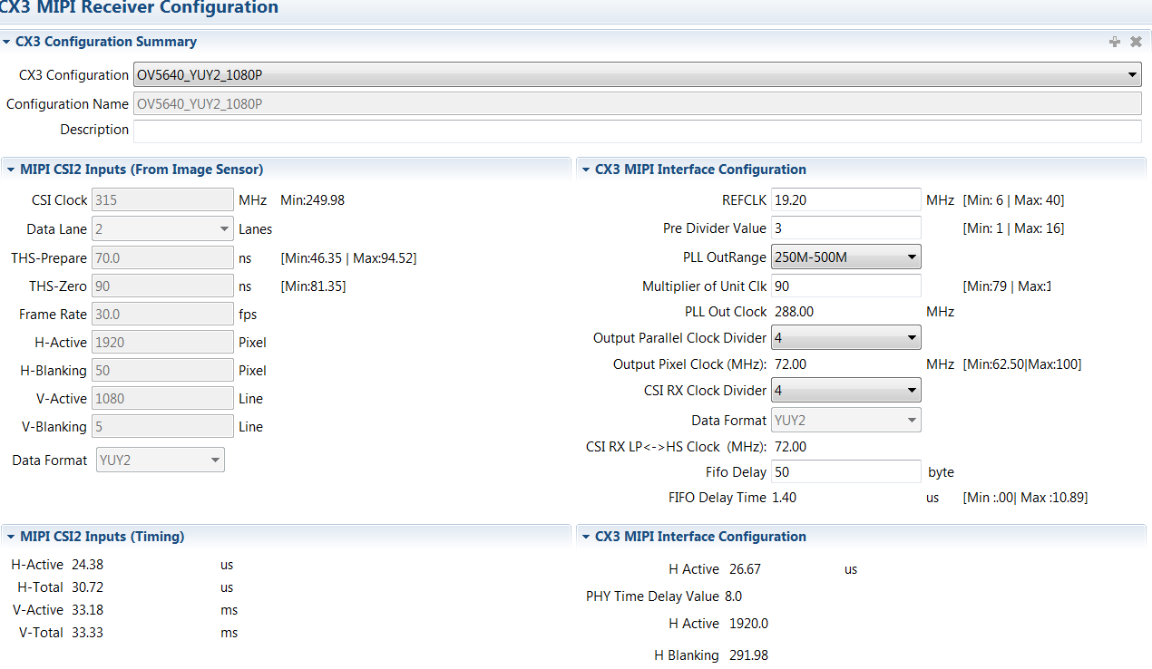
Fig 5. CX3 MIPI Receiver configuration page

- Configure the MIPI CSI-2 block clocks. These values will be applied to configure the PLL of CX3. For more information, please refer to the section 1.7 of CX3 TRM here. It is also available at the install path of EZ-USB FX3 SDK C:\Program Files (x86)\Cypress\EZ-USB FX3 SDK\1.3\doc\firmware. Enter or choose the value according to your application. Make sure that all the values are within the correct range.
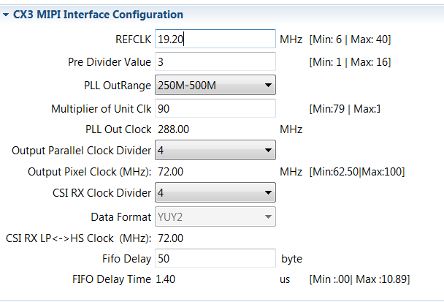
Fig 6. CX3 MIPI CSI-2 block clocks

- Check and save all the files generated by the configuration tool.
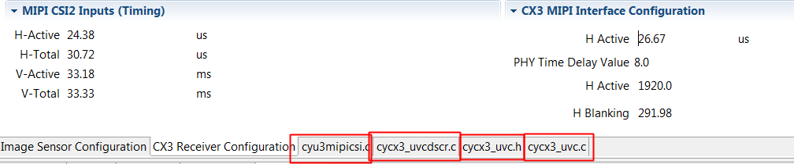
Fig 7. Save all the files

Note:
- Four files will be created here. Cyu3mipicsi.c consists of the structure(s) CyU3PMipicsiCfg_t which will be used to configure the PLL of CX3 according to the required resolution(s). Cycx3_uvcdscr.c is the descriptor file which includes all the structures for communication with the host. Cycx3_uvc.h is the necessary header file. Last but not the least, cycx3_uvc.c includes the all the codes to enumerate CX3 as an UVC device, initialize CX3 and start/stop video streaming.
- It could be found that cyu3imgasensor.c and cyu3imgagesensor.h are also created and saved in this project. Cyu3imagesensor.c is used to configure, control the image sensor. In this file, some structures are defined without valid value. Customer just need to replace them with actual settings. Generally used APIs such as CyCx3_ImageSensor_Sleep, CyCx3_ImageSensor_Wakeup, CyCx3_ImageSensor_Trigger_Autofocus are also stated here. Add the corresponding codes into these definitions.
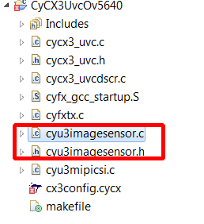
Fig 8. Project explorer view
- The configuration tool helps customer setup a new project template from the very beginning. Customer could modify the project to implement other applications basing on this template. In addition, the tool can be used to check the values when adding a new resolution to the previous project. Be careful to the save icon since it will overwrite the whole file if have written codes to implement other functions.
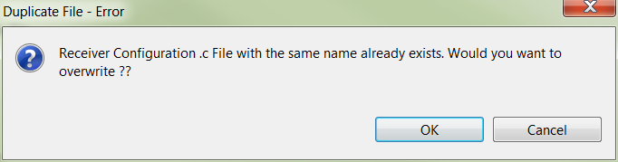
Fig 9. Be careful to overwrite a file

- Save and build the project. EZ-USB SDK should generate image file. If failed, check the console output message to locate the root cause.
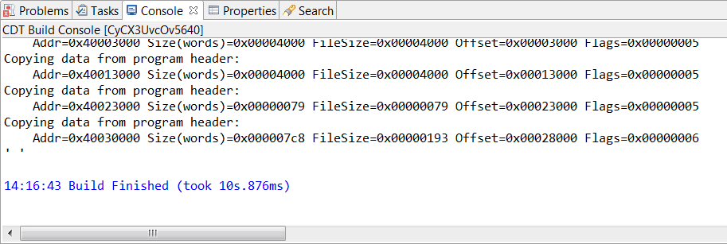
Fig 10. Build the project

Related Categories:
Keywords: [CX3 MIPI CSI-2]
Product Family: [SS_USB, HSLS_USB]
Related Tags: [Select the Tags by clicking the checkbox associated to the Tags]

Clocks & Buffers Tags

Adapter | Algorithm | Bitmap | Buffer | Bypass | CLKMAKER
CML | CY3670 | CY3672 | CY3675 | CY36800 | Cascade
Charge Pump | Clock Tree | Clocks | Clocks and Buffers | ComLink | Crystal Oscillators
CyClock | CyClockWizard | CyberClocks | CyberClocks Online | Cycle to Cycle | DCXO
Delay | Deterministic Jitter | Differential | Divider | Duty Cycle | EMI
Enhanced Performance | Ent | Entrant | FNOM | Factory | Failsafe
Fanout | FastEdge | Feedback | Field | Flexo | Frequency
Frequency Margining | Function Select | Generators | Ground Bounce | HPB | HSTL
Hershey Kiss | I2C | IBIS Model | Impedance | Input | InstaClock
Inverted | Jed | Jedec | Jitter | LVCMOS | LVDS
LVPECL | Layout | Lexmark Profile | Loop Bandwidth | MoBL | Modulation Rate
Multiplier | NZDB | Non-Volatile Memory | OTP | Offset | Oscillator
Output | Overvoltage | PCI Express | PLL | PPM | PREMIS
Period | Phase | Phase Noise | Power Supply Noise | Program | Programmable
Propagation | Pullability | RMS | Rambus | Random Jitter | Reference
Rise Fall Time | RoboClock | Schematic | Serial | Signal Integrity | Skew
Socket | Specialty Clocks | Spread % | Spread Aware | Spread Profile | Spread Spectrum
Synthesizer | TCXO | TIE | Termination | Thermal | Translator
Undervoltage | UniClock | Unit Interval | VCO | VCXO | Volatile Memory
Voltage Droop | XCG | XDR | XO | Xtal | ZDB
Zepto

Lighting & Power Control Tags

Board Layout | Boost Regulator | Buck Regulator | CY3261 | CY3267 | CY3268
CY3269 | Color Mixing | Current Sense | DALI | DMX | FN Pins
HB LEDs | Hysteretic Controller | MOSFETs | MPPT | Modulators | PrISM
Programming | SSDM | Schematics | Switching Regulators | Trip | Voltage Regulator

Wireless/RF Tags
2.4 GHz | 8DR | Antenna | Audio | AgileHID | Bridge
CY3271 | CY3630 | CY4636 | CY4672 | CYFI | CYFISNP
CYRF6936 | CYRF7936 | Channel | DDR | DSSS | GFSK
HID | HUB | IRQ | Interference Avoidance | Keyboard | Link Budget
Mouse | Node | PMU | PN Code | PRoC | PRoC-CS
PRoC-EMB | PRoC-TT | PRoC-USB | PRoC-UI | Power Amplifier | Preamble
Pseudo Noise code | RF | RSSI | Range | Remote | SCD
SDR | SOP | SPIM | Star-Network Protocol | Streaming | Trackpad
Wireless | Wireless USB | Wireless USB LP | Wireless USB LS | Wireless USB LR | Wireless USB NL
Wireless Capacitive Touch

Memory Tags

Address Bus | Async | Automotive | Autostore | BHE / BLE | BUSY
Battery Backup | Burst | Bus Contention | Clock | DDR | Data Bus
Data Integrity | Data Retention | Datasheet | Dual Port | Echo Clocks | FIFO
FPGA | Flags | Flowthrough | Fullflex | FRAM | HOLD
HD-FIFO | HSB | I2C | INT | Impedance Matching | Interface
Interleaving | JTAG | Junction Temperature | Low Power | MSL | Migration Path
MoBL | Models | NoBL | ODT | Obsolete | PCB
PLL / DLL | Packaging | Parallel | Parity | Part Decoder | Part Difference
Password Protection | Pin Configuration | Pipeline | Power Consumption | Power On State | Processor
QDR | Qualification Reports | Quality | RECALL | RTC | Race Condition
Read | SER | SPCM | SPI | SRAM | Serial
Signal Integrity | Sync | Technology | Termination | Timing | Vcap
Vddq | Voltage Levels | Vref | Width / Depth Expansion | Write | nvSRAM
uPower

Interface Tags

10B/8B Decoder | 3 Level Inputs | ALDEC | ATM | Altera | BIST
BSDL | Biasing | CDR | CML | CPLD | CY3900i
CY3950i | CYUSBISRPC | Cable | Cable Driver | Channel Bonding | Clock Multiplier
Clocking Modes | Coaxial Cable | Copper Cable | Coupling | Crystal | Current
DVB | Data Character | Data rate | Delta39K | Deserialize | Deserializer
Dual Channel | EPLD | EPROM | ESCON | Elasticity Buffer | Equalizer
Error | Evaluation Board | FPGA | Fiber Optics | Flash370i | Framer
Framing Character | Framing Mode | Gigabit Ethernet | Hex | High Speed Serial Links | Hotlink
HotlinkI | HotlinkII | IP | Isr | Jtag | LFI
LVTTL | Logic Level | Loop Back | Macrocell | Max340 | Model
Non-Volatile | OC-1 | OC-2 | OC-3 | Operating System | PAL
PECL | PLD | PLL | Parallel Input | Parallel Output | Parity
Phase Align Buffer | PoF | Point To Multi Point | Point To Point | Power Supply | Programming
Quad Channel | Quantum38K | Receiver | Recovered Clock | Redundant Outputs | Reference Clock
Report File | Reprogrammable | SMA | SMPTE | SMPTE-259M | SMPTE-292M
SONET | SPICE | SPLD | STAPL | SVF | Serial Input
Serial Output | Serializer | Simulator | Size | Special Character | Specification
TTL | Temperature | Third Party Tool | Transceiver | Transmitter | USBISRPC Cable
Ultra37K | User Guide | VHDL | Verilog | Voltage | Warp
Word Sync Sequence
PSoC 1 Tags

ADC | ADCINC | Analog | Analog Bus | API | Assembly Language
Boot.asm | Bootloader | BSDL Files | Build Errors | Calibration | Capsense
Clock | Clock Synchronization | Cloning | Column Clock | Communication | Comparator
Compiler | Counter | CPU Speed | Crystal | CT Block | DAC
Debugging | Decimator | Delta Sigma ADC | Development Kit | Digital | Dynamic Reconfiguration
ECO | EEPROM | Errata | Filter | Flash | Flash Security
Global Resources | GPIO | Hex File | I2C | I2C-USB Bridge | ICE Cube
Installation | Internet Explorer | Interrupt | ISR | ISSP | Large Memory Model
LCD | License | MAC | MiniProg1 | MiniProg3 | Mux
Mux Bus | OCD | Offset | Pod | Port and Pins | Power Management
Production Programmer | PWM | RAM | RTC | SAR | SC Block
SMP | SPI | System Level Design | Timer | UART | USB
USBUART | Watchdog | Amplifier UM | Analog Reference | Analog UM | Build Tools
Communication UM | CRC UM | CYFI | Device Programming | Digital UM | DTMF
Fan Controller UM | Firmware UM | FMEA | Port Expander | PSoC Power System Architecture | Voltage Sequencer UM

PSoC 3/4/5 Tags

Component Tags
Analog Hardware Mux | Analog Mux | Boost Converter | Bootloader / Bootloadable | CAN | CapSense_CSD
Character LCD | Clock | Comparator | Control / Status Register | Counter | CRC
DAC | Debouncer | Delta Sigma ADC | DFB | DFB Assembler | Die Temperature
Digital Comparator | Digital Multiplexer | DMA | EEPROM | emFile SPI Mode | EMIF
EzI2C Slave | Fan Controller | Filter | Frequency Divider | Glitch Filter | Global Signal Reference
Graphic LCD | I2C /I 2S | iAP | Interrupt | LIN | Logic Gates
Lookup Table | Manual Routing | MDIO | Mixer | Opamp | PGA
Ports and Pins | Power Monitor | PRS | PWM | Quadrature Decoder | Resistive Touch
RTC | RTD Calculator | Sample / Track and Hold | SAR ADC | SAR Sequencer | Segment LCD
SGPIO | Shift Register | Sleep Timer | SM / PMBus | SPDIF | SPI
Sync | Thermistor Calculator | Thermocouple Calculator | TIA | Timer | TMP05 Interface
TrimMargin | UART | UDBClkEn | USBFS | USBMIDI | USBUART (CDC Interface)
Voltage Fault Detector | Voltage Sequencer | Vref | WaveDAC
General Tags
Analog Bus | Analog Global Bus | Analog Mux Bus | API | Application Specific | Assembly Language
Bootloader Host | Boundary Scan / BSDL | Bridge Control Panel | Build Settings | Clock | Compiler - GCC
Compiler - KEIL | Compiler - MDK | Compiler - RVDS | Cortex-M0 | Cortex-M3 | Creator Registration
Custom Component Interconnect | Datapath Configuration Tool | Debugging | DMA Wizard | DVK | ECO
Errata | Error Message | Flash | Hex File | Installation | ISSP / HSSP
KEIL Registration | Linux Platform | Low Power Modes | LVD / HVD | MFi | MiniProg3
Optimization | Programmer COM | PSoC Creator | PSoC Programmer | Reset | RTOS
Schematic | Silicon | Software Download | STA | Supply Voltage | System Reference Guide
Verilog | Watchdog | Windows Platform
Kit Tags
CAN / LIN EBK | CapSense Expansion EBK | CY8CKIT-001 Kit | CY8CKIT-030 / 050 Kit | CY8CKIT-042 Kit | Digital Audio EBK
First Touch Kit | LCD Segment Drive EBK | MFI EBK | Power Supervisor EBK | PSoC 3/4/5 Processor Module | Thermal Management EBK

Touch Sensing Tags

ADC | Air gap | Backlighting | Bleeder Resistor | Bootloader | CMOD
CSA | CSD | CSD Parameters | CSD2X | CSDADC | CSDAUTO
CY3203A | CY3213A | CY3214 | CY3218 | CY3280-20x34 | CY3280-20xx6
CY3280-21x34 | CY8C20x34 | CY8C20xx6 | CY8C21x34 | CY8C21xxx-CapSense Express | CY8C24x94
CY8CMBR2044 | CapSense Express | Circuit Housing | Conductive Objects | Configuration | Diplexing
Dynamic Reconfiguration | EEPROM | EMI | ESD | Errors | FR4
Filters | Finger Threshold | Flex PCB | I2C | I2C-USB Bridge | IDAC
IMO and Prescaler | ITO | Layout Guidelines | Metal | Noise | Overlay
PSoC3 CapSense | Parasitic Capacitance | Pathfinder | Power Consumption | Proximity | SNR
SPI | Scanning Techniques | Schematic | Sensors | Shield | Sliders
SmartSense | Tuning | UART | Water | Water Proofing

USB Controllers Tags

8051 | AN2131 | AT2LP | ATA / ATAPI | ATA Commands | Asynchronous
Auto Mode | Bandwidth | Blaster | Bulk Transfer | Bus Power | C#
C++ | CAT5 | CF Card | CY3216 | CY3649 | CY3654
CY3655 | CY3660 | CY3662 | CY3664 | CY3674 | CY3681
CY3684 | CY3685 | CY3686 | CY4605 | CY4606 | CY4611B
CY4615 | CYUSB | Clock | Compliance | Control Center | Control Transfer
Crystal | CyConsole | DLL | Debug | Descriptors | Driver
EEPROM | EZ-HOST | EZ-OTG | EZ-USB | Emulation | EnCoreII
EnCoreIII | EnCoreV | Encore | Endpoint | Enumeration | Errata
FIFO | FX | FX1 | FX2 | FX2LP | Firmware
Firmware Debug | Flags | Framework | Full Speed | GPIF | HDD
HID | HX2 | HX2LP | Hi-Lo Programmer | High Speed | Host Application
Hub | I2C | ICE | IN Transfer | Interrupt Transfer | Interrupts
Isochronous Transfer | Keil | Keyboard | Layout | Library | Loader
Low Speed | M8A | M8B | Manual Mode | Mass Storage | Memory
Mouse | NX2LP | NX2LP-Flex | Nand Flash | Nand Manufacturing Utility | OTP
OUT Transfer | Port IO | Register | Renumeration | Report | Reset
SFR | SIE | SL811HS | SPI | SX2 | Schematic
Schematic Review | Screamer | Script | Self Power | Slave FIFO | Streaming
SuiteUSB | Synchronous | TX2 | TX2UL | Tetra Hub | Throughput
Timer | UART | UDMA | USBFS | USBUART | USBSerial
Vendor Command | Video Class | WHQL | WLK | cyapi | uVision
SuperSpeed
FX3 | ADMux | ARM926EJ -S | Bootloader | DMA | Eclipse
FX3 GPIO | FX3 Power Management | FX3 Power supply | FX3 SDK | GPIF II | HS-OTG
JTAG | LPP | MSC | Oscillator | RTOS | SD Card
Slavefifo | USB 3.0 | USB Compliance Test | USB Host | UVC
FX3S | eMMC | SDIO | S-Ports | Bay | Benicia
HX3 | ASSP | Battery charging | Bootloader | Cortex-M0 | EEPROM
GPIOs | HX3 Power Management | HX3 Power supply | I2C | In-system programming | Oscillator
USB 3.0 hub | USB Shared Link™

Automotive MCU Tags

Traveo | S6J3110 | S6J3120 | S6J3200 | S6J3300 | S6J3310
S6J3320 | S6J3330 | S6J3340 | S6J3350 | S6J3400 | S6J3500
S6J326C | S6J324C | S6J327C | S6J328C | S6J32DA | S6J32BA
S6J3360 | S6J3680 | S6J32G0
FR81S | MB91520 | MB91550 | MB91580 | MB91570 | MB91590
FCR4 | MB9DF120 | MB9EF220 | MB9D560 | F2MC-16FX | MB96300
MB96600 | MB96800 | CAN | CAN FD | LIN | Flexray
Ethernet | AUTOSAR | Serial | Timer | Watchdog | A/D Converter
SHE | Security | Current | Interrupt | Graphics | Document
CPU | Clock | Mode | Reset | Real Time Clock | BootROM
Flash Memory | RAM | Backup RAM | MPU | PPU | DMA
Multi-Function Serial | UART | CSIO | I2C | Base Timer | QPRC
CRC | Port | External Bus | DDR HSSPI | Hyper Bus | Parity
PSS | Low Power | SMC | LCDC | Media LB | DAC
Audio DAC | I2S | PCMPWM | Sound | APIX | Motor
Wave Generator | RDC | MVM | Flash Programmer | Tool

Knowledge Base Article Type: [Select the category by clicking the checkbox associated]

KB Type-1 | KB Type-2
Compiler | ByteCraft
 | Imagecraft
 | Keil
 | HiTech
Component Development | Training/Things you should know
 | Component Architecture
 | Component/Project management
 | Datapath
 | Analog components
 | Digital components
 | Component software/tools
 | Component Testing
Development Kits | FirstTouch Kit
Development Tools
Device Drivers | Pullability
 | Mass Storage
Device Programming | PSoC Programmer
Documentation
Firmware
General
Hardware | Digital
 | Specifications
 | Analog
Known Problems and Solutions
Microcontrollers | 8051
 | M8
 | M8C
 | Traveo
 | FCR4
 | FR
 | F2MC
Modules
Platforms | MacOS X
 | Windows
Protocols | HID
 | I2C
Quality
Reference Designs
Software | PSoC Designer
 | PSoC Creator
User Modules | Analog
 | Digital

Document History
Document Title: The general steps to setup up MIPI CSI camera solution with CX3.
Document Number: 002-25748
Rev. | ECN No. | Orig. of Change | Description of Change
** |  | YYCA | Created KBA.

