Jlink Programming
- You have to make connections as per the following snip. The image provides which pins of the header in the 43907 eval board corresponds to the pinout of the Jlink debugger.
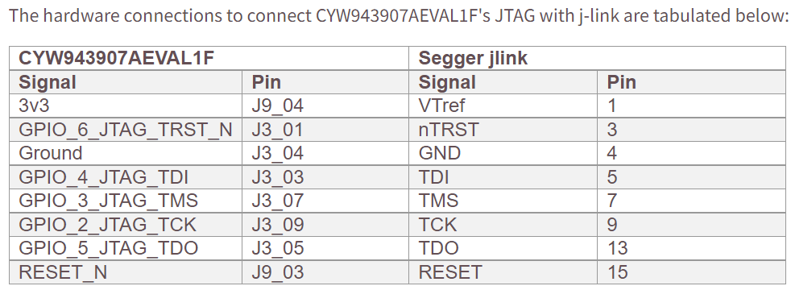
- The switches in SW4 on CYW943907AEVAL1F need to be ON to use an external JTAG. (By default, the switches are off).
- Connect the Jlink segger to host PC. To download an application using j-link Segger, you need to change the jlink driver to libusbK. Check the following snip for device manager snap.
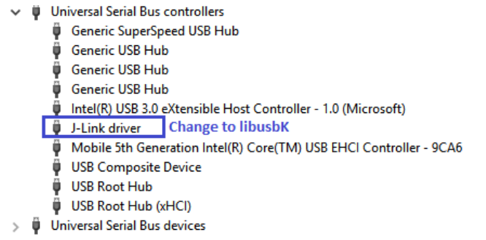
- Use Zadig to change the jlink driver. Check following snip. Check the device manager of the host PC to verify that J-link segger appears under libusbK USB devices.
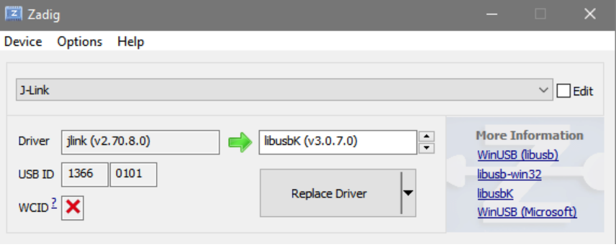
- Modify the configuration file( tools/OpenOCD/BCM4390x.cfg) to include the mode flags as follows:
replace reset_config srst_nogate connect_assert_srst with
reset_config trst_and_srst srst_push_pull srst_nogate connect_assert_srst

- To build and download a scan application for debugging using external JTAG, the make target should contain "JTAG=jlink" in the build string.
Make the target as: snip.scan-CYW943907AEVAL1F-debug JTAG=jlink download run

Make sure that the download happens successfully and the hex/elf file gets generated

Jlink Debugging

First Stage –
The steps involve the same process that is followed in the case of Jlink programming if not done before. Make sure to follow the above steps and generate the hex/elf file as that will be required for the debugging process.
Second Stage –
- To debug an application, you need to revert back the driver for jlink from libusbK to Segger. Right click on jlink under libusbK and update driver. Choose "Search automatically for updated driver software". This will install the jlink driver. Jlink will appear as J-link driver under Universal Serial Bus Controllers.

If it doesn’t appear under Universal Serial Bus Controllers, then select “Browse for drivers on your computer”, then select “Let me pick from a list of available drivers on my computer”. From the options select “Jlink driver” and then click on “Next”. Jlink will appear as J-link driver under Universal Serial Bus Controllers.

- Disable the Watchdog by adding the following flag in the make file of your application:
GLOBAL_DEFINES += WICED_DISABLE_WATCHDOG

- Follow the instructions given below for setting the debug configurations in WICED SDK. Create a new Eclipse debugger launch configuration for SEGGER J-Link:
- Go to Eclipse menu → Run → Debug Configurations, double click the GDB SEGGER J-Link Debugging group, or select it and then click the top leftmost New button, this will create a new configuration with a multi-tab page displayed as below.
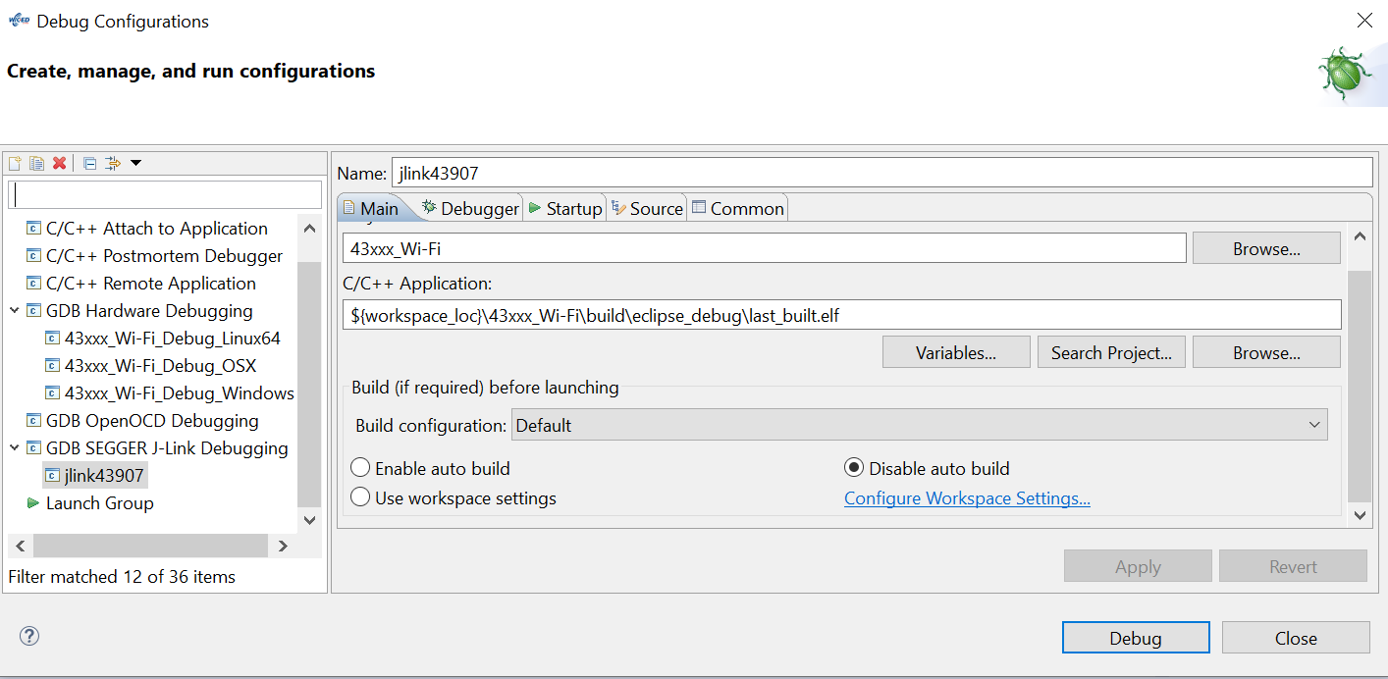
- First, in Main tab. Check the Name field; you may give it any name you preferred, like “jlink43907”.
C/C++ Application: ${workspace_loc}\43xxx_Wi-Fi\build\eclipse_debug\last_built.elf

- Choose the debugger tab
Do the settings as per the given images below-
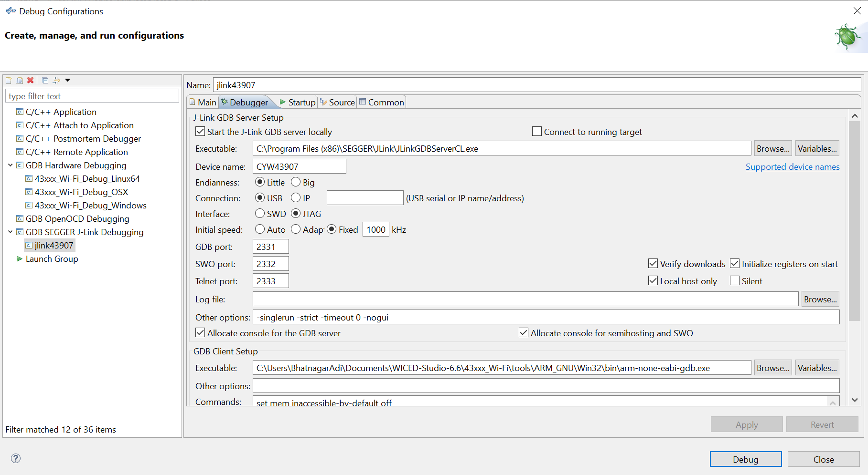

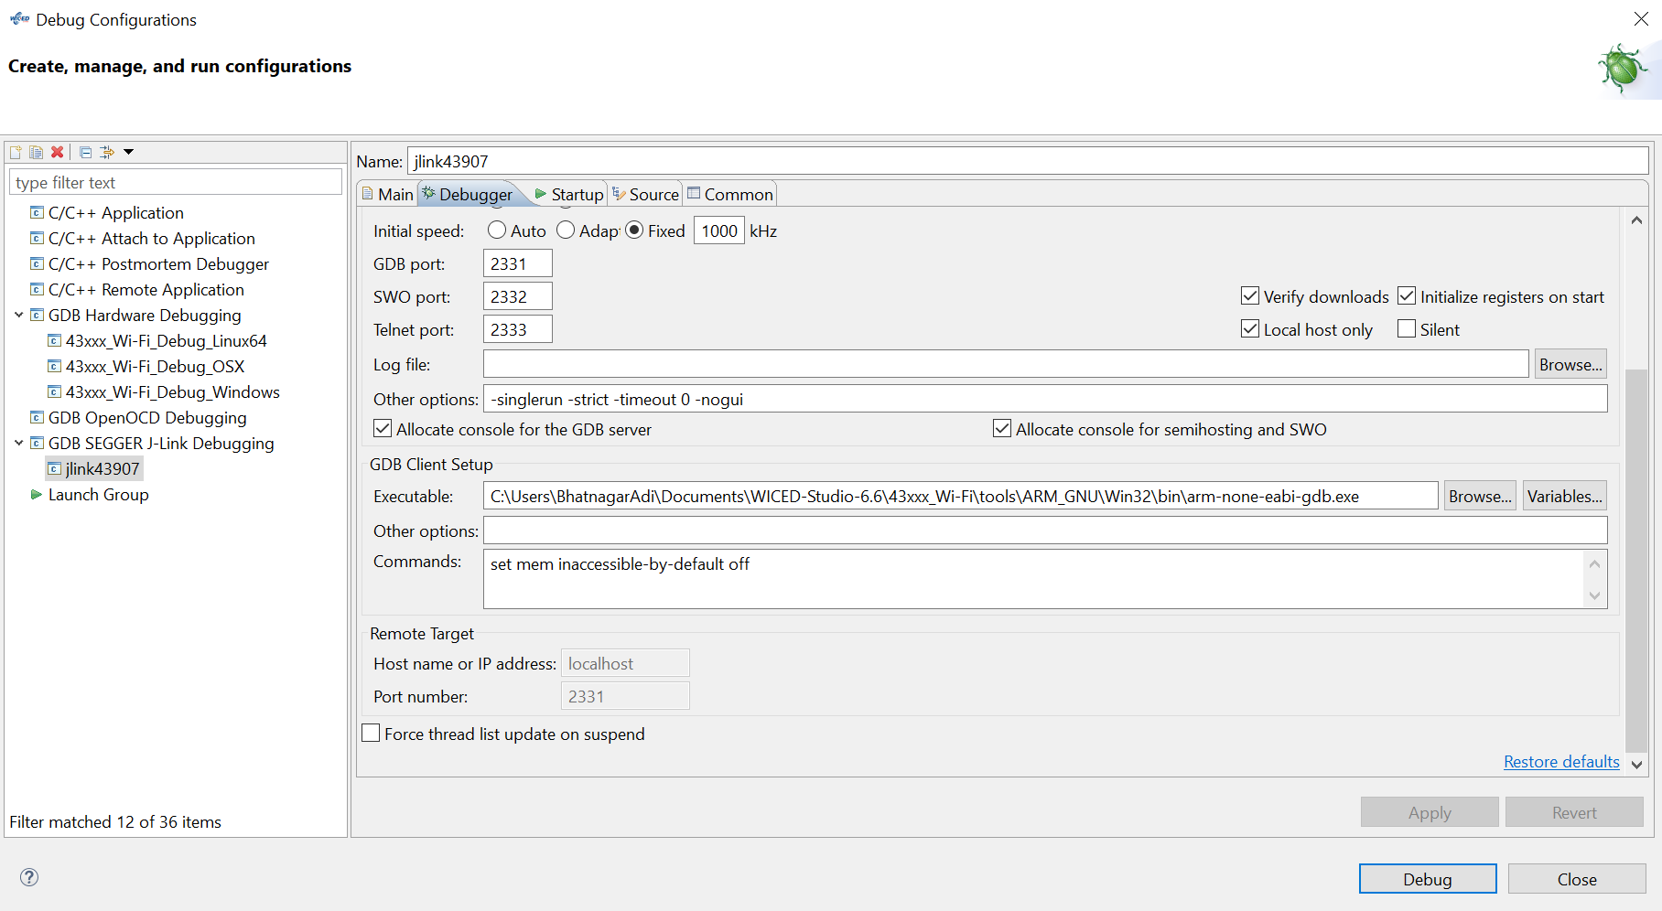
- Choose the startup tab
Do the settings as per the given images below-

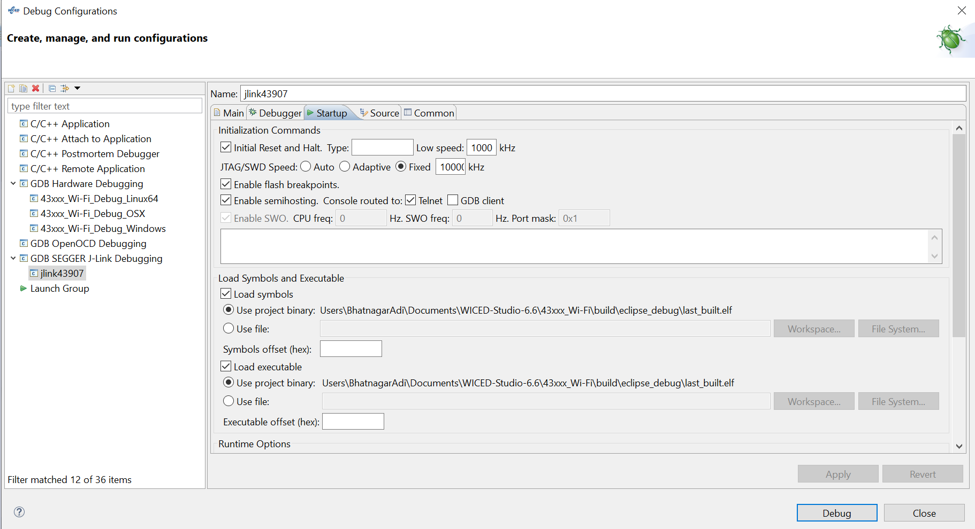

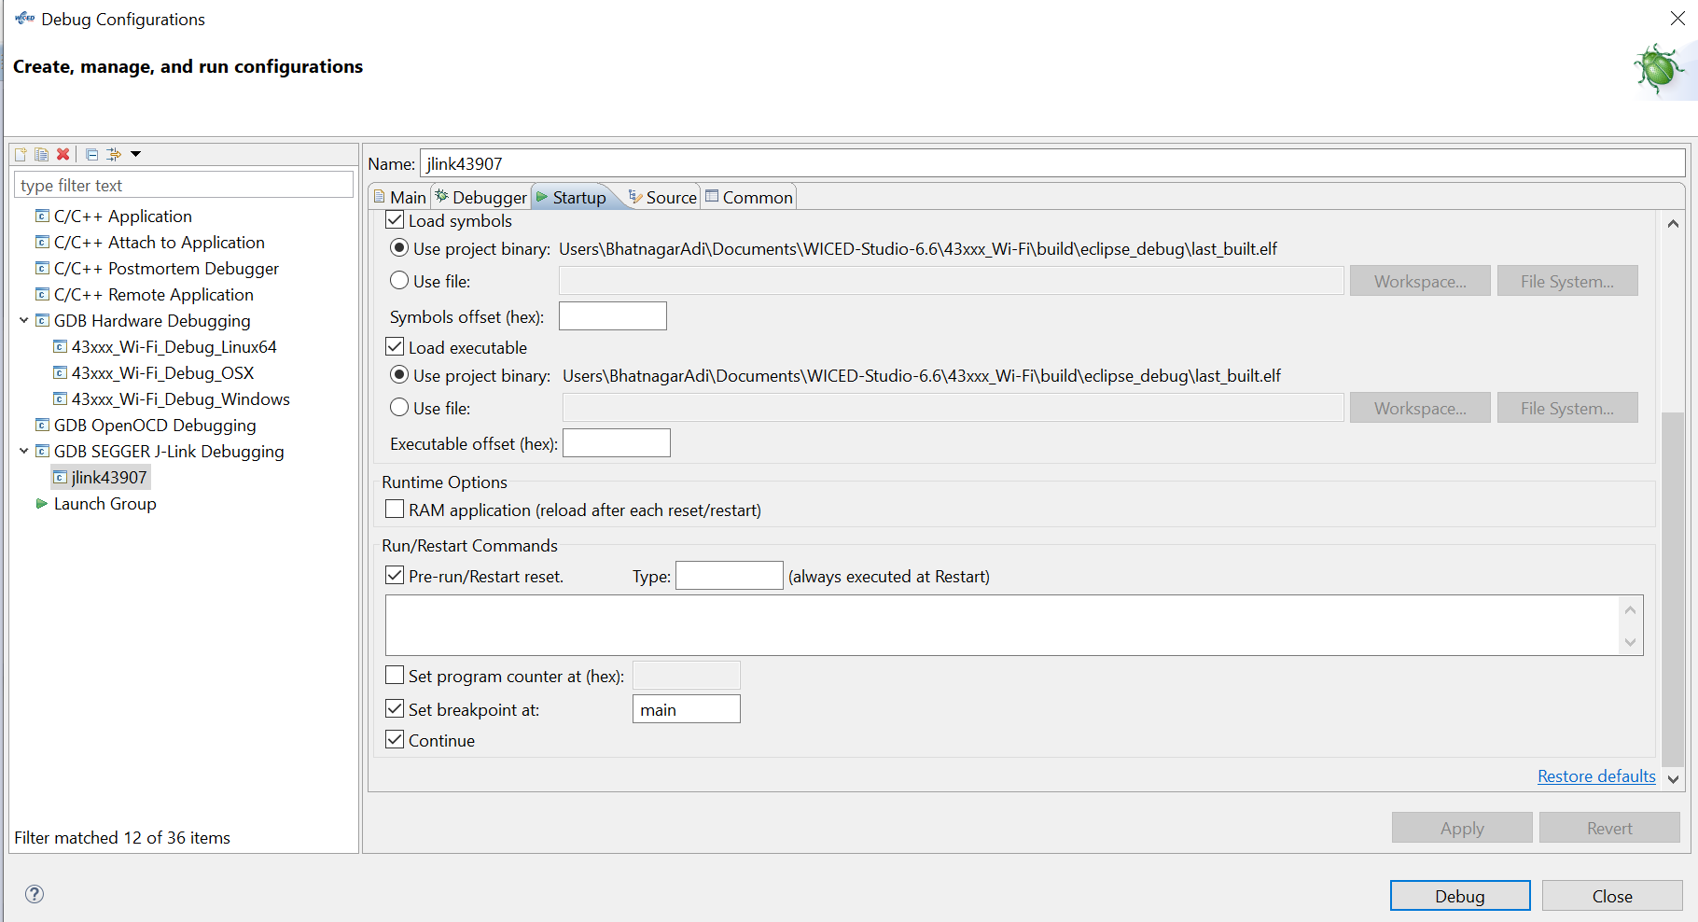
- No settings are required in the Source tab.
The common tab settings are as shown-
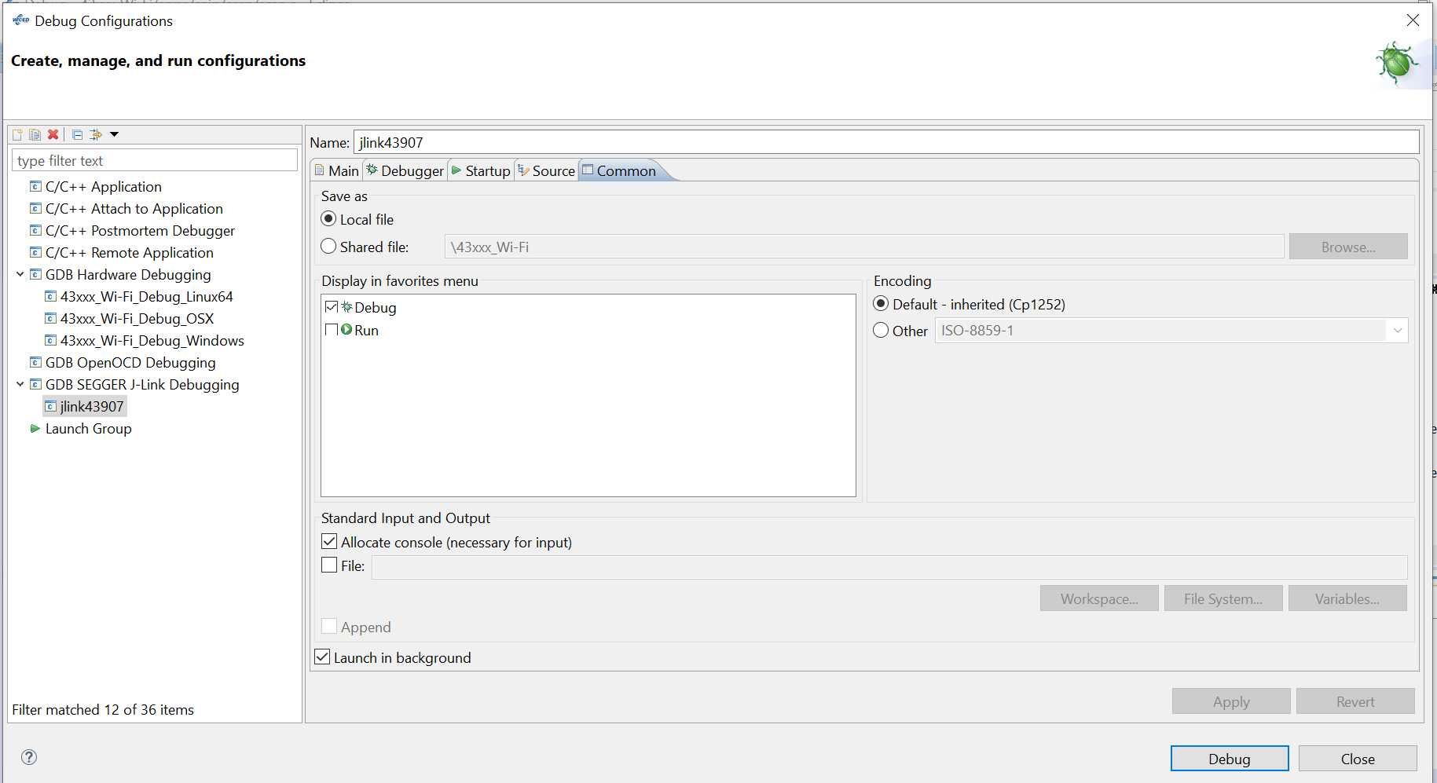
Click the Apply button after above settings. Then click the Close button to complete the new configuration creation. With the above settings, the debug configuration will be saved in the Eclipse project.

Starting the debug session

- Click the bug specific icon. By default, this will start the previously used debug launch configuration; to start a different configuration, click the down arrow button near the icon, and select the configuration you made for SEGGER J-Link.

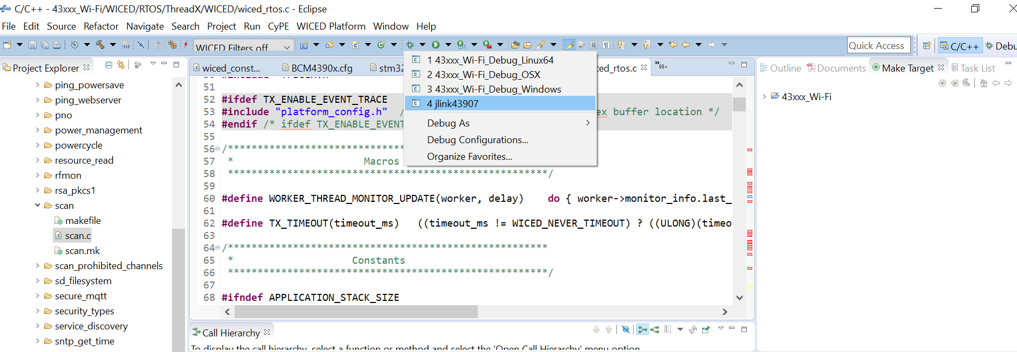
- If everything is ok, after a few seconds required to start GDB Server, to allow it to connect to the target, start GDB Client, download the application and start the debugging session, you should see something like below:

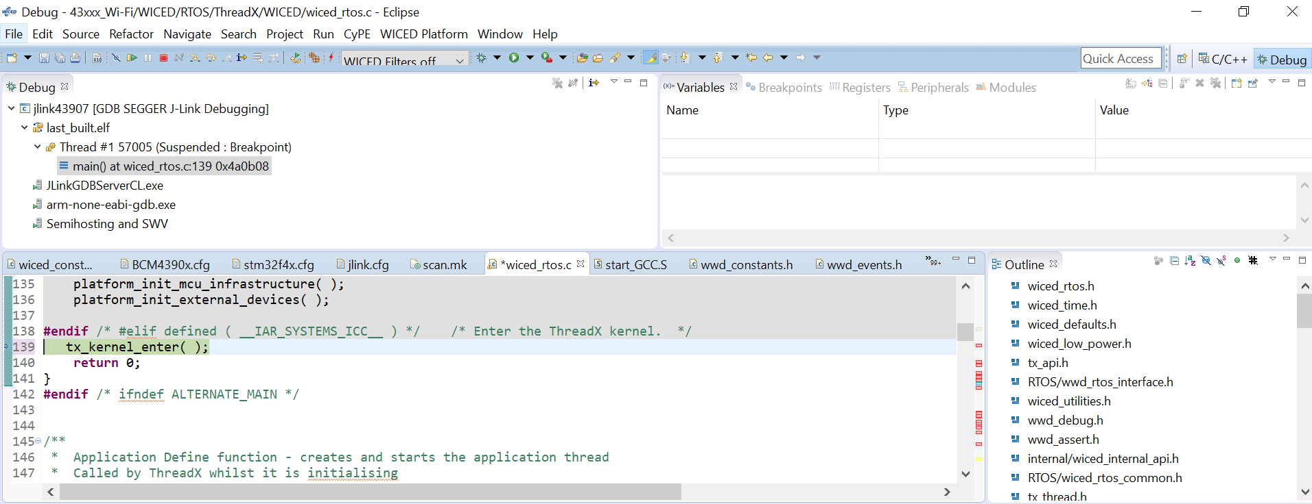

- After debug session started successfully, you may try clicking Resume icon to run program or Suspend icon to halt:

