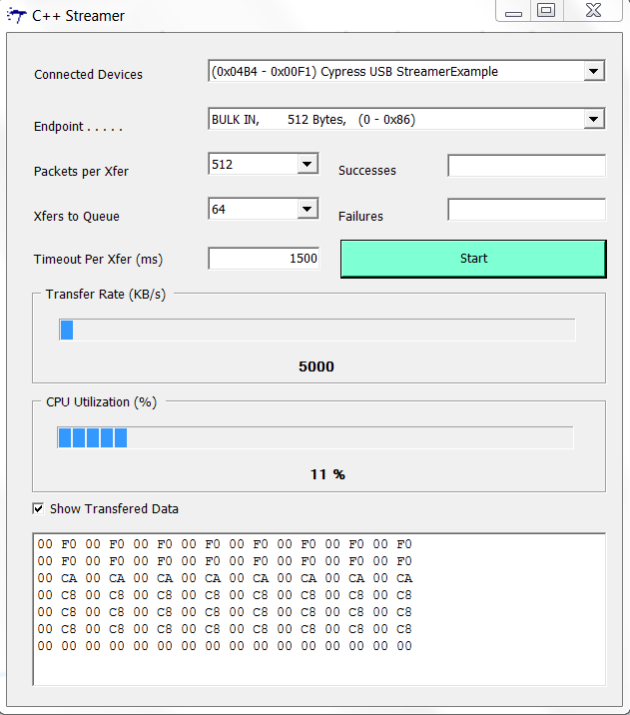
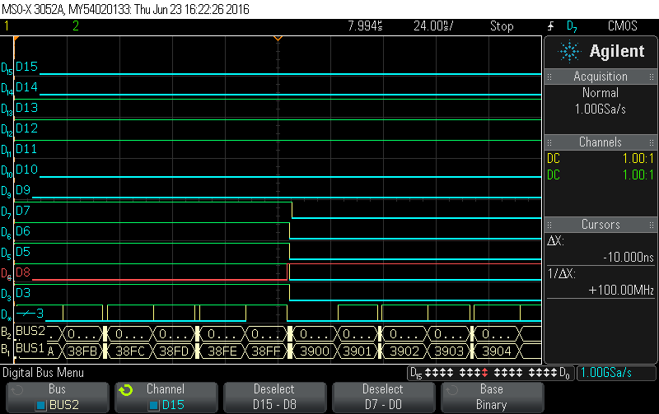
Figure 2 Output data from FPGA
Figure1 Received Data from FPGA to FX2 Board.

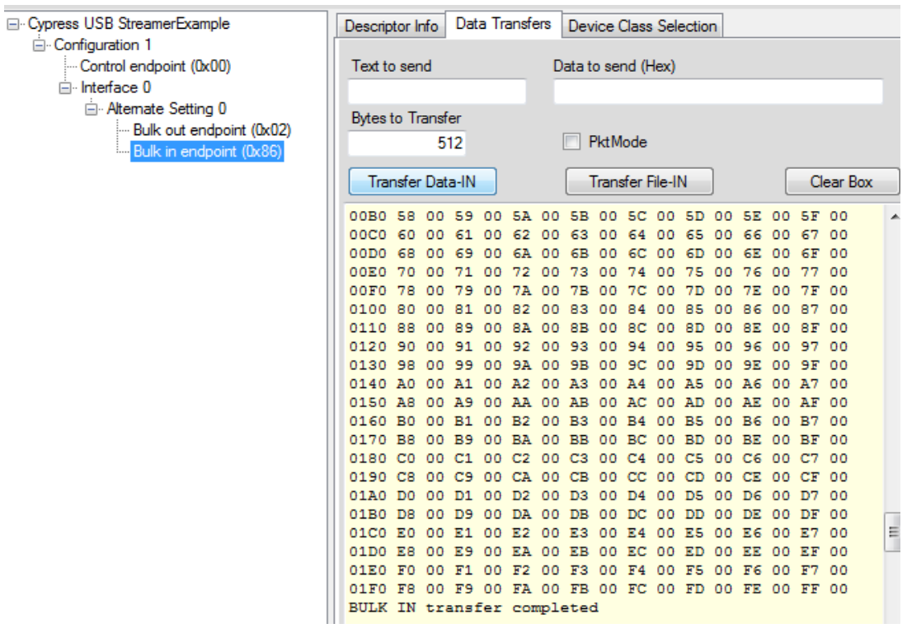

Figure 3 Expected Received Data from FPGA to FX2 Board.
The code :-
----------------------------------------------------------------------------------
library IEEE;
use IEEE.STD_LOGIC_1164.ALL;
use IEEE.STD_LOGIC_ARITH.ALL;
use IEEE.STD_LOGIC_UNSIGNED.ALL;
--library UNISIM;
--use UNISIM.vcomponents.all;
entity fx2lp_slaveFIFO2b_streamIN_fpga_top is
Port (
reset_n_out : out STD_LOGIC; --used for TB
reset_in_n : in std_LOGIC;
fdata : inout STD_LOGIC_VECTOR(15 downto 0); -- FIFO data lines.
faddr : out STD_LOGIC_VECTOR(1 downto 0); -- FIFO select lines
slrd : out STD_LOGIC; -- Read control line
slwr : out STD_LOGIC; -- Write control line

flagd : in STD_LOGIC; --EP6 full flag
flaga : in STD_LOGIC; --EP2 empty flag
clk : in STD_LOGIC; --Interface Clock
sloe : out STD_LOGIC; --Slave Output Enable control
clk_out : out STD_LOGIC;
pkt_end : out STD_LOGIC;
done : out STD_LOGIC;
sync : inout std_logic
);
end fx2lp_slaveFIFO2b_streamIN_fpga_top;
architecture fx2lp_slaveFIFO2b_streamIN_fpga_top_arch of fx2lp_slaveFIFO2b_streamIN_fpga_top is
component pll_fx2lp is
port(
rst : in std_logic;
outclk_0 : out std_logic;
refclk : in std_logic);
end component pll_fx2lp;

component ddr
port(
datain_h : in std_logic;
datain_l : in std_logic;
outclock : in std_logic;
dataout : out std_logic);
end component;
--streamIN fsm signal
type stream_in_state is (stram_in_idle, stream_in_write);
signal current_stream_in_state, next_stream_in_state : stream_in_state;
signal slrd_n, slwr_n, sloe_n,slrd_d_n : std_logic;
--signal CLK_OUT_0, clk_out_90, clk_out_180, CLK_OUT_270 : std_logic;
signal clk_100 : std_LOGIC;
signal reset_n : std_logic;
signal lock : std_logic;
signal data_out : std_logic_vector(15 downto 0);
signal done_d : std_logic;
signal wait_s : std_logic_vector(3 downto 0);

begin --architecture begining
--pll instantiation
pll_fx2lp_inst : component pll_fx2lp
port map(
rst => not reset_in_n,
outclk_0 => clk_100,
refclk => clk
);

ddr_inst : ddr
port map(
datain_h => '0',
datain_l => '1',
outclock => clk_100,
dataout => clk_out
);
--for TB
reset_n_out <= reset_n;
--output signal asignment
sync <= '1';
reset_n <= sync;
slwr <= slwr_n;
slrd <= slrd_n;
sloe <= sloe_n;
faddr <= "10";
pkt_end <= '1';
done <= done_d;
fdata <= data_out;

process(clk_100, reset_n) begin
if(reset_n = '0')then
done_d <= '0';
elsif(clk_100'event and clk_100 = '1')then
if(wait_s = "1010")then
done_d <= '1';
end if;
end if;
end process;
process(clk_100, reset_n) begin
if(reset_n = '0')then
wait_s <= "0000";
elsif(clk_100'event and clk_100 = '1')then
if(wait_s < "1010")then
wait_s <= wait_s + '1';
end if;
end if;
end process;
--write control signal generation
process(current_stream_in_state, flagd)begin
if((current_stream_in_state = stream_in_write) and (flagd = '1'))then
slwr_n <= '1';
else
slwr_n <= '0';
end if;
end process;
--streamIN mode state machine
streamIN_mode_fsm_f : process(clk_100, reset_n) begin
if(reset_n = '0')then
current_stream_in_state <= stram_in_idle;
elsif(clk_100'event and clk_100 = '1')then
current_stream_in_state <= next_stream_in_state;
end if;
end process;
--LoopBack mode state machine combo
streamIN_mode_fsm : process(flaga, flagd, current_stream_in_state) begin
next_stream_in_state <= current_stream_in_state;
case current_stream_in_state is
when stram_in_idle =>
if((flagd = '1') and (sync = '1'))then
next_stream_in_state <= stream_in_write;
else
next_stream_in_state <= stram_in_idle;
end if;
when stream_in_write =>
if(flagd = '0')then
next_stream_in_state <= stram_in_idle;
else
next_stream_in_state <= stream_in_write;
end if;

when others =>
next_stream_in_state <= stram_in_idle;
end case;
end process;

--data generator counter
process(clk_100, reset_n) begin
if(reset_n = '0')then
data_out <= "0000000000000000";
elsif(clk_100'event and clk_100 = '1')then
if(slwr_n = '0')then
data_out <= data_out + '1';
end if;
end if;
-- end if;
end process;

end architecture;

