- Select the device from device manager. In your case, please select CY7C68001.

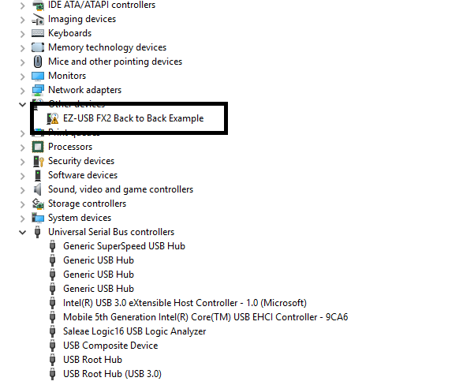

- Right on the device and choose the “Update driver” option.
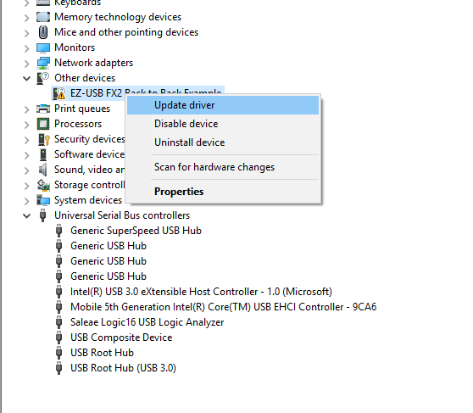

- Select “Browse my computer for driver software” option.

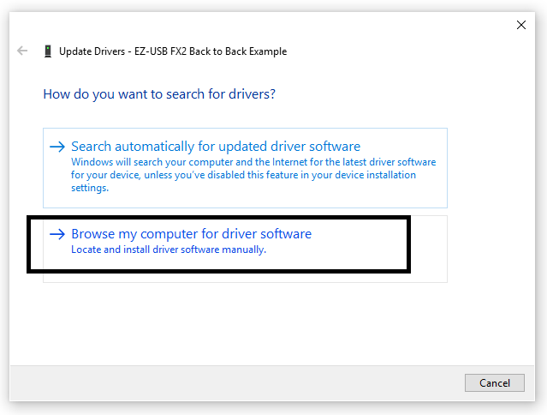

- Next, select “Let me pick from a list of available drivers on my computer” option.

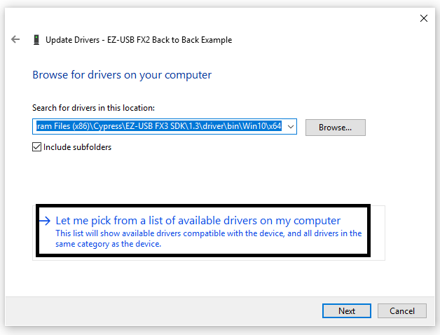

- Click on “Show All Devices” and then “Next”.

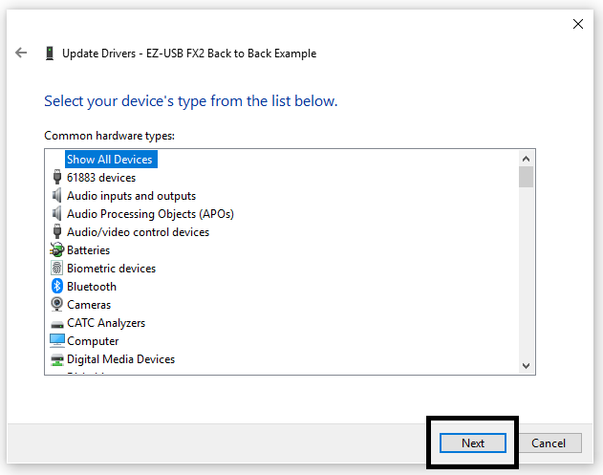

- Now select “Have Disk”.

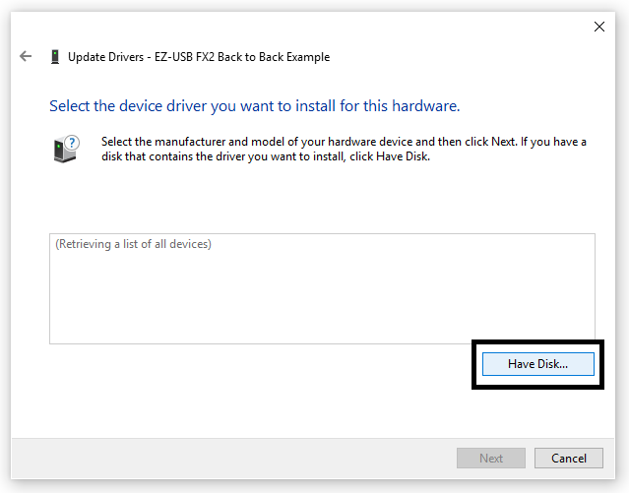
- In the popup window, click on “Browse”.

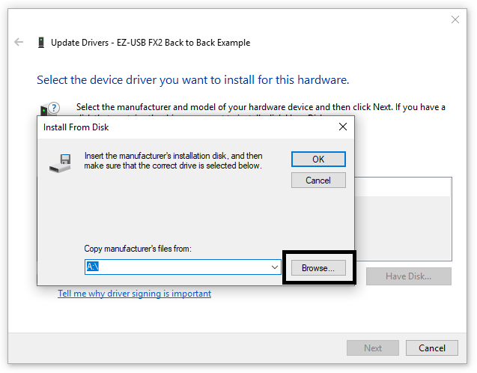

- Navigate to the folder where you have saved the driver folder. Go to the appropriate OS version folder and then architecture folder for your host PC. Once the *.inf file is seen in that path as shown below, click on “Open”.

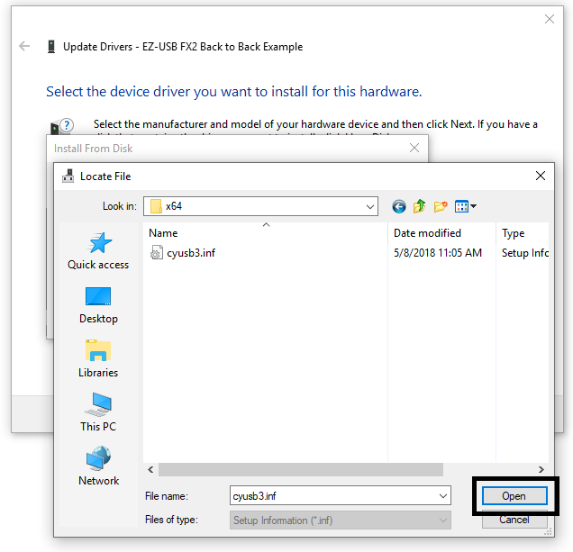

- Ensure that the correct path appears in the box as per your selection in step 8 and click “OK”.

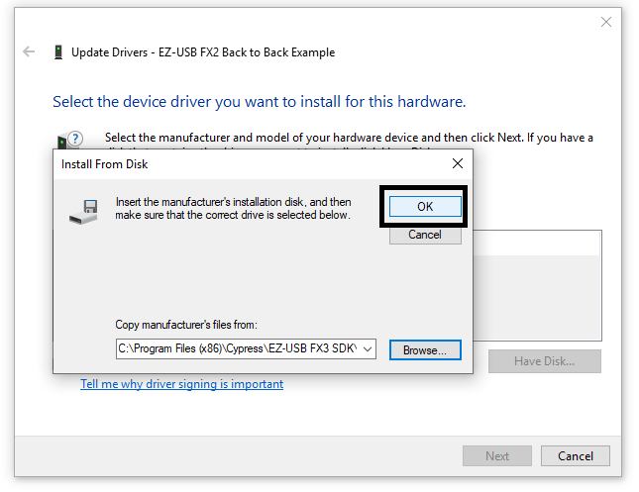

- Select a suitable model from the list that the device will enumerate with. If SX2 is not present on the list, select any other suitable name. Once the binding is complete, the device will be visible with that name in the device manager. Click “Next”.

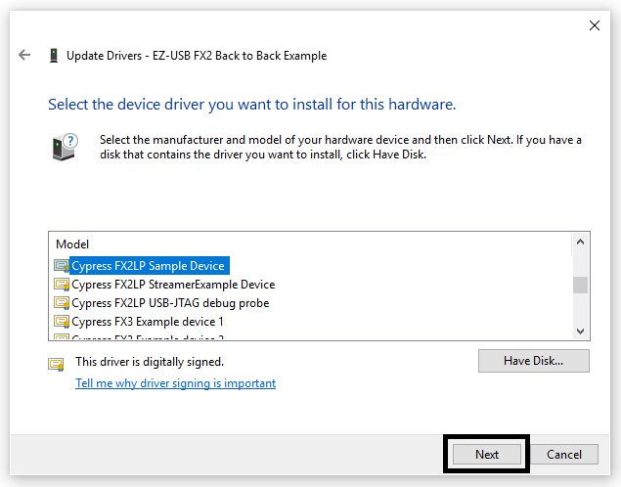

- Click “Yes” if the warning appears on your PC.

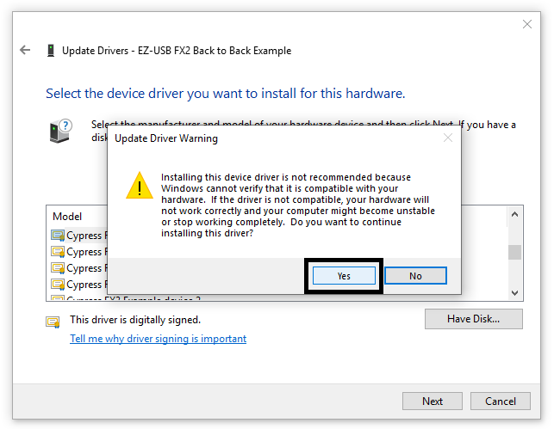

- If the driver binding is completed successfully, the below message will appear and the device should be present without any yellow mark in the device manager.

