- SCH
FPGA part, HyperRam pins (HR_*) connect to different banks.
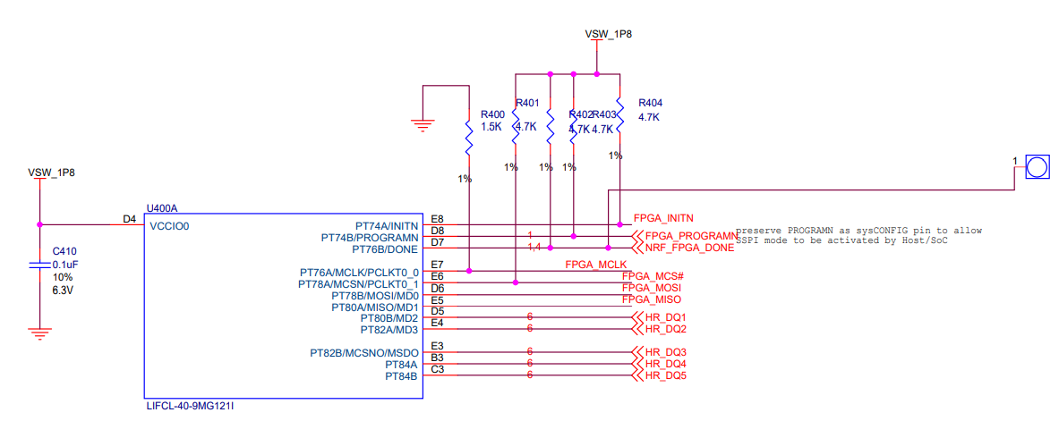

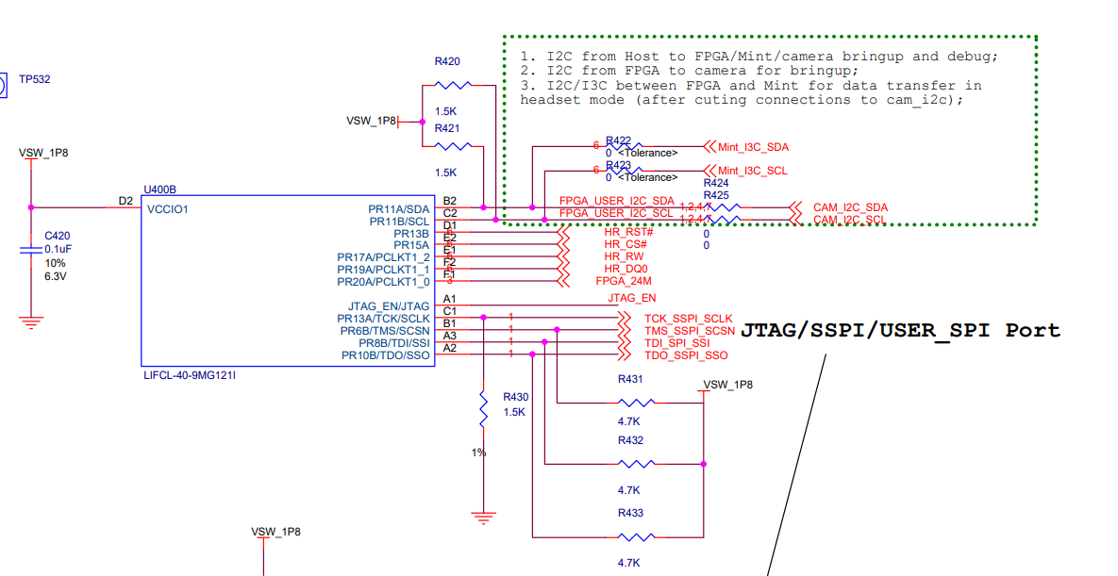

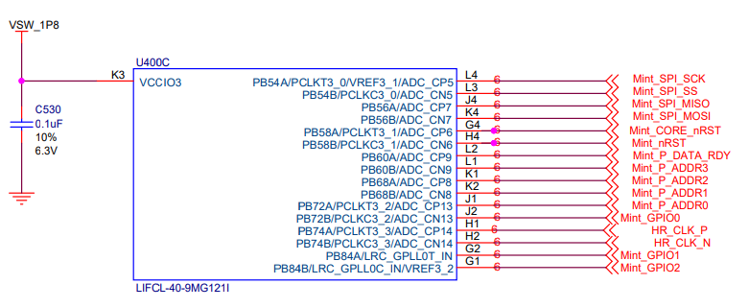

HyperRam:
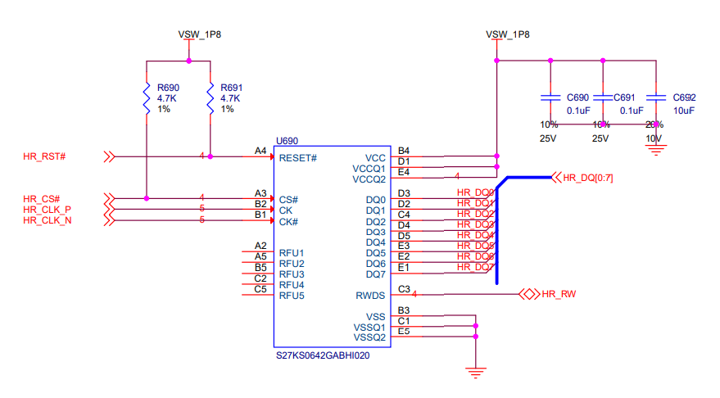

2. All below waveforms are from Reveal logic analyzer in Lattice Radiant software.
Writing 8x64bits data, starting from address 0:
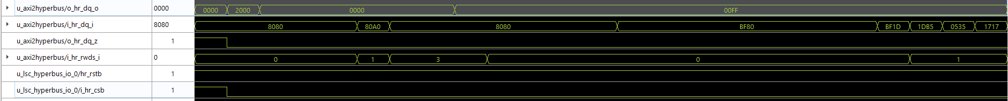
reading 1x64bits data from address0:
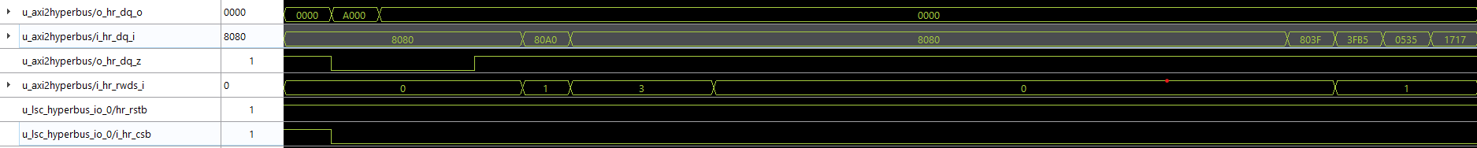
Read ID0:
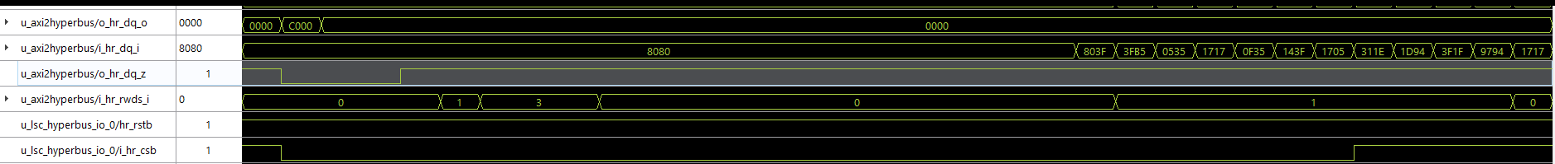
- Please note all those signals are before FPGA IO buffers, I am not able to probe HyperRan pins except DQ6 and DQ7.
- I confirmed the waveform from DQ7 matches the waveform of merged signal from i_hr_dq_i[15] and i_hr_dq_i[7] ( i_hr_dq_i is the 16bist bus after iddr from physical HR_DQ bus of HyperRam, similar for i_hr_rwds_i). So that means HyperRAM does respond.
- If I hold reset at low, I will read all 0 values which is reasonable

